Name: Krish Singh
Roll: AID25072
B.Tech Artificial Intelligence & Data Science - 2nd Semester
Object Oriented Programming – Lab Assignment 11

LAB Sheet Solutions:

HelloGUI:
import javax.swing.*;
public class HelloGUI{
public static void main(String[] args){
JFrame frame = new JFrame("Hello");
JLabel label = new JLabel("Hello, Swing");
frame.add(label);
frame.setSize(300,150);
frame.setDefaultCloseOperation(JFrame.EXIT_ON_CLOSE);
frame.setVisible(true);
}

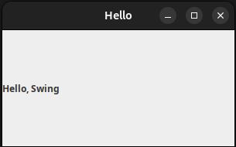
Output:

ButtonClick.java:

Code:
import javax.swing.*;
import java.awt.*;
public class ButtonClick{
public static void main(String[] args){
JFrame frame = new JFrame("Button Example");
frame.setLayout(new FlowLayout());
JButton button = new JButton("Click me");
button.addActionListener(e->{
JOptionPane.showMessageDialog(frame,"Button Clicked");
});
frame.add(button);
frame.setSize(300,150);
frame.setVisible(true);
frame.setDefaultCloseOperation(JFrame.EXIT_ON_CLOSE);
}
}
Output:
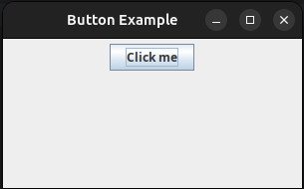
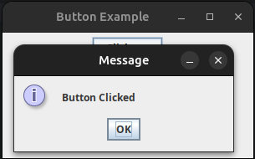

InputDisplay.java:

Code:
import javax.swing.*;
import java.awt.*;
public class InputDisplay {
public static void main(String[] args) {
JFrame frame = new JFrame("Input Examplese");
frame.setLayout(new FlowLayout(FlowLayout.CENTER));
JTextField input = new JTextField(10);
JButton button = new JButton("Show");
JLabel label = new JLabel();
button.addActionListener(e->{
label.setText("You enetered: "+input.getText());
});
frame.add(input);
frame.add(button);
frame.add(label);
frame.setSize(300,150);
frame.setDefaultCloseOperation(JFrame.EXIT_ON_CLOSE);
frame.setVisible(true);
}
}

Output:
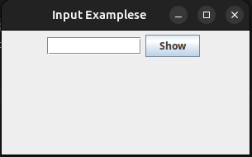
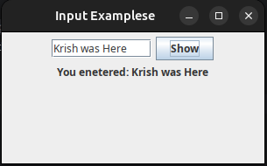

Calculator.java:

Code:
import javax.swing.*;
import java.awt.*;
public class Calculator{
public static void main(String[] args){
JFrame frame = new JFrame("Calculator");
frame.setLayout(new FlowLayout());
JTextField num1 = new JTextField(10);
JTextField num2 = new JTextField(10);
JButton add = new JButton("ADD");
JLabel label = new JLabel();
add.addActionListener(e->{
try{
int a = Integer.parseInt(num1.getText());
int b = Integer.parseInt(num2.getText());
label.setText("Sum is: "+(a+b));
}
catch(Exception ex){
label.setText("Invalid Input");
}
});
frame.add(num1);
frame.add(num2);
frame.add(add);
frame.add(label);
frame.setSize(300,150);
frame.setDefaultCloseOperation(JFrame.EXIT_ON_CLOSE);
frame.setVisible(true);
}
}
Output:
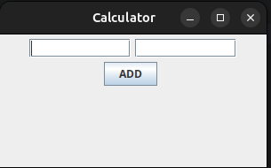
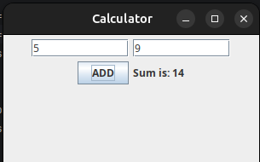

ToDoApp.java:
Code:
import java.awt.*;
import javax.swing.*;
public class ToDoApp{
public static void main(String[] args){
JFrame frame = new JFrame("To Do List");
frame.setLayout(new FlowLayout());
JTextField input = new JTextField(10);
JButton add = new JButton("ADD");
JButton remove = new JButton("Remove");
DefaultListModel<String> model = new DefaultListModel<>();
JList<String> list = new JList<>(model);
add.addActionListener(e->{
if(!input.getText().isEmpty()){
model.addElement(input.getText());
input.setText("");
}
});
remove.addActionListener(e->{
int index = list.getSelectedIndex();
if(index!=-1){
model.remove(index);
}
});
frame.add(input);
frame.add(add);
frame.add(remove);
frame.add(new JScrollPane(list));
frame.setDefaultCloseOperation(JFrame.EXIT_ON_CLOSE);
frame.setSize(300,250);
frame.setVisible(true);
}
}

Output:
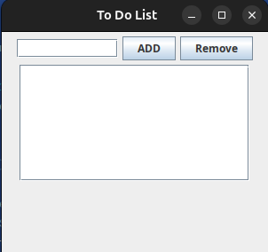
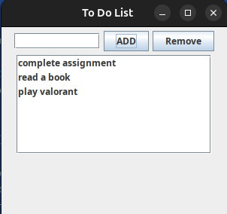
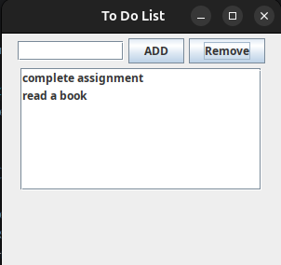

FoodOrderApp.java:

Code:
import javax.swing.*;
import java.awt.*;
public class FoodOrderApp extends JFrame {
private JCheckBox pizza, burger, juice;
private JTextArea output;
public FoodOrderApp() {
setTitle("Food Ordering app");
setSize(500,500);
setLayout(new FlowLayout());
setDefaultCloseOperation(JFrame.EXIT_ON_CLOSE);
pizza = new JCheckBox(" Pizza -> 100 rs");
burger = new JCheckBox("Burger -> 80 rs");
juice = new JCheckBox("juice -> 50rs");
JButton billButton = new JButton("Calculate Bill");
output = new JTextArea(8,25);
output.setEditable(false);
add(new JLabel("Selected items"));
add(pizza);
add(burger);
add(juice);
add(billButton);
add(new JScrollPane(output));
setVisible(true);
billButton.addActionListener(e-> calculateBill());
}
private void calculateBill() {
int total=0;
StringBuilder bill = new StringBuilder("Selected items: \n");
if(pizza.isSelected()){
total+=100;
bill.append("Pizza -> 100rs \n");
}
if(burger.isSelected()){
total+=50;
bill.append("Burger -> 80rs \n");
}
if(juice.isSelected()){
total+=50;
bill.append("juice -> 50rs \n");
}
bill.append("Total: ").append(total).append("\n");
output.setText(bill.toString());
}
public static void main(String[] args) {
SwingUtilities.invokeLater(()-> new FoodOrderApp());
}
}

Output:
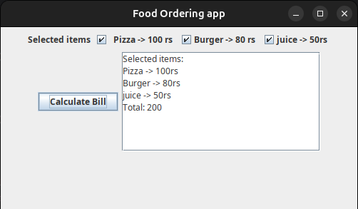

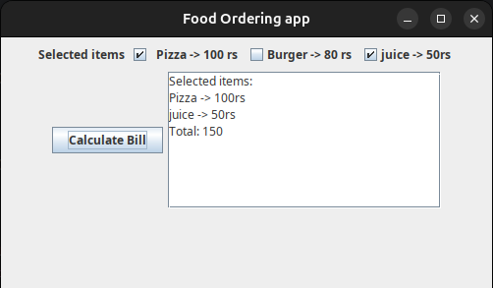

Lab Assignment Task 2

StudentGradeEvaluator.java:
Code:

import javax.swing.*;
import java.awt.*;
public class StudentGradeEvaluator {
public static void main(String[] args){
JFrame frame = new JFrame("Grade Evaluator");
frame.setLayout(new FlowLayout());
JLabel front = new JLabel("Evaluate grade for Krish: ");
JTextField marks1 = new JTextField(3);
JTextField marks2 = new JTextField(3);
JTextField marks3 = new JTextField(3);
JButton evaluate = new JButton("Evaluate");
JTextArea output = new JTextArea(5,50);
evaluate.addActionListener(e->{
try{
int m1 = Integer.parseInt(marks1.getText());
int m2 = Integer.parseInt(marks2.getText());
int m3 = Integer.parseInt(marks3.getText());
StringBuilder s = new StringBuilder();
int total = m1+m2+m3;
s.append("Total marks: ").append(total).append("\n");
float average = (float)total/3;
s.append("Average marks: ").append(average).append("\n");
char grade;
if(average>=75){
grade = 'A';
}
else if(average>=60){
grade = 'B';
}
else if(average>=40){
grade = 'C';
}
else{
grade = 'F';
}
s.append("Grade: ").append(grade);
output.setText(s.toString());
}
catch(Exception ex){
output.setText("Invalid input Marks");
}
});
frame.add(front);
frame.add(marks1);
frame.add(marks2);
frame.add(marks3);
frame.add(evaluate);
frame.add(new JScrollPane(output));
frame.setSize(300,200);
frame.setDefaultCloseOperation(JFrame.EXIT_ON_CLOSE);
frame.setVisible(true);
}
}

Output:

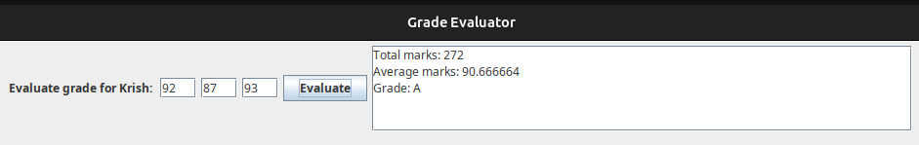
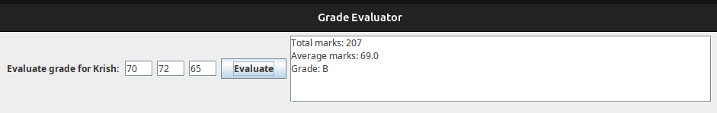
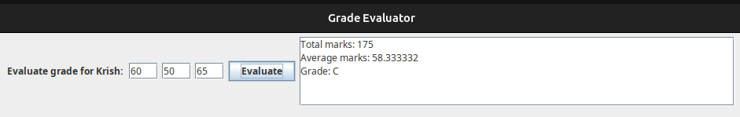
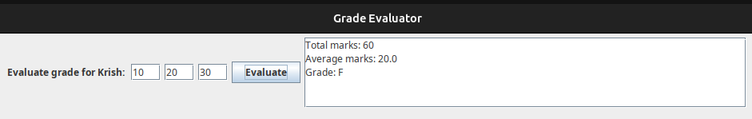

Post-Lab Questions

1. What is the role of Jframe?
Ans: Jframe is the main window of any swing application. It acts as a top level container that holds all other components like buttons, labels, and text fields. Without a Jframe, there is no visible window. It provides the title bar, borders and close/minimize/maximize controls. Every Swing app starts by creating a Jframe and adding componenets into it.

2. What is an event in GUI?
Ans: An event is any user action that the program needs to respond to. Examples include clicking a button, typing in a text field, moving the mouse or pressing a key. In Swing, events are automatically detected by the framework and passesd to the appropriate listener if one has been registered. Events are what makes a GUI interactive rather than just static display.

3. How does ActionListener work?
Ans: ActionListener is an interface that listens for action events, most commonly button clicks. You attach it to a component using addActionListener(). When the user performs the action (like clicking the button), the actionPerformed() method is automatically triggered and executes whatever code you put inside it. In modern Java, this is written using lambda expression like e→ {..} instead of writing a full class.

4. Why is exception handling required in GUI input?
Ans: Because users can type anything inside a text field – letters, symbols, spaces etc when numbers are expected. If we try to convert that input using Integer.parseInt() without a try-catch block and the user types “abc” the program will crash entirely. Exception handling catches that error gracefully and instead displays a helpful message like “Invalid Input”, keeping the application running smoothly.

5. What is the role of Timer in Swing?
Ans: javax.swing.timer is used to execute code repeatedly at fixed time inervals without freezing the GUI. For Example, it can be used to build a countdown clock, animate something on screen, or auto-refresh data every few seconds. It is important to use Swing’s own Timer (not java.util.Timer) because Swing is single-threaded – all UI updates must happen on Event Dispatch Thread (EDT) and Swings Timer runs on that thread automatically, keeping the interface responsive.

